Computational Thinking in K-12 Education
October 25, 2017 featured, Uncategorized

What is Computational Thinking?
Computational Thinking is the process of formulating a problem, finding solution to the problem and expressing it in such a way that humans or machines can understand the solution. It involves the use of problem solving methods to decompose the problem into smaller manageable sub problems, identifying the right abstractions so as to deal with scale and complexity, finding existing patterns or models that can be adapted, building an algorithm to solve the problem and in case of multiple solutions, analysing the solutions on multiple parameters to identify the one that best meets the given situation.
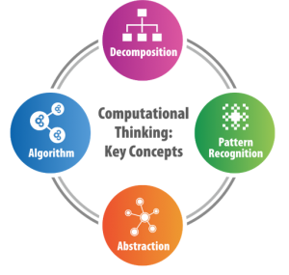Computational thinking is an analytical thinking skill that draws on concepts from computer science but is a fundamental skill useful for everyone (Wing[2006]). Computational thinking as a practice is central to all sciences and not just computer science. There is hardly any profession where computers and computational methods are not used. New disciplines have come up in the past decades or so due to the advancement in computational methods. Computational thinking concepts are used in other disciplines including biology, health, retail, transportation, history, journalism, finance, and archaeology. Students who can think computationally are better able to conceptualise, understand and use technology, helping them to be better prepared for the future.

It is said that by middle of 21st century Computational skills would be essential skills like reading, writing and arithmetic! This is why it becomes imperative that we teach Computational Thinking in schools

Computational Thinking in K-12 Education
The National Research Council (NRC) (NRC [2010]) has highlighted the importance of exposing students to computational thinking notions early in their school years and helping them to understand when and how to apply these essential skills. Computer Science Teachers Association (CSTA https://www.csteachers.org/) and the International Society for Technology in Education (ISTE https://www.iste.org/) have presented a computational thinking framework for K-12 schools in 2011 with core computational thinking concepts and capabilities, including data collection, data analysis, data representation, problem decomposition, abstraction, algorithms and procedures, automation, parallelization, and simulation (CACM [2017]).
Algorithms are central to both computer science and computational thinking. Algorithms underlie the most basic tasks everyone performs, from following a simple cooking recipe to providing complicated driving directions. There is a general misconception that algorithms are used only to solve mathematical problems and are not applicable in other disciplines whereas there are enough examples from daily lives that require us to use algorithms. For example, the steps involved in brushing teeth, getting ready for school, steps performed during a lab experiment etc. Understanding and articulating algorithms as a sequence of precise steps helps us develop an algorithm that can be understood by a human or a machine, in the latter case implemented by a computing program. Students can be exposed to the computational thinking concept of abstraction by creating models in physics (such as a model of the solar system). Abstraction helps students learn to strip away complexity and unnecessary detail to focus only on the important parts of the problem. A number of leading research, educational, and funding organizations have argued for the need to introduce K-12 students to these core constructs and practices.

Why teach Maths in Computational Thinking curriculum?
Do you agree that mathematics is required for every profession? Why? What does mathematics have that makes it a foundational skill for every profession? Apart from basic counting, it helps us think logically – we break down a problem and solve it one step at a time. More importantly, it teaches us “abstraction” which is an essential concept when dealing with complex problems. It can help develop our problem solving, critical thinking and reasoning abilities. These are the foundational skills required for Computer Science and computational thinking. So it is important to include these aspects of mathematics and relevant examples into computing curriculum.
Unfortunately the current mathematics curriculum in schools does not do enough justice to developing these skills. So curricula teaching Computer Science or computational thinking include these aspects of mathematics. One of the unintended side effects might be that seeing and working on mathematics examples through fun and activity based learning, students will develop better and improved understanding of concepts and perhaps overcome fear of Maths!
Children learn to solve puzzles, design algorithms, get to know better ways to sort things, identify patterns, know of hierarchy, plan things better, etc. If you observe, all these skills are useful in daily life too and not just in computing! Ask someone for directions to reach a landmark and you will realize that you need to ask a number of people before you reach the destination. Why is that so? It is because instructions provided are incomplete and confusing and we have not learnt to give precise and clear instructions.

Teaching Computing without using computers
The primary goal of teaching Computational Thinking is to develop ability to solve problems and express the solution in the form of an algorithm that is precise and can be understood by a human or a machine. Experts feel that the above does not require the use of computers and can be taught as a series of interesting, engaging and fun activities. We want to convey that computing concepts and fundamentals do not depend on particular technology or software or programming languages. Technology has a short shelf life and will serve our children for the next few years, whereas, fundamentals will stay with them for several decades.
This avoids confusing Computer Science with programming or learning application software, makes the activities available to those children who do not have access to computers, and overcomes the hurdle of having to learn programming before being able to explore ideas and articulating solutions as algorithms. We want students to realize that they are capable of finding solutions to problems on their own, rather than being given a solution to apply to the problem. For example children play the game of Tic-Tac-Toe and then develop the rules of the game as well as winning positions.
The focus of the CSpathshala curriculum is to work towards developing problem solving and computational thinking as foundational skills amongst students and train them to be creators & inventors of technology and not just users of technology!
With Computational Thinking, you will see your children getting smarter day by day. We also encourage you to go through the material yourself and see the progression of topics across grades – it is available for free!

References:
- Tucker, F. Deek, J. Jones, D. McCowan, C. Stephenson, and A. Verno. 2006 A Model Curriculum for K-12 CS (2nd ed.). http://csta.acm.org/Curriculum/sub/CurrFiles/K-12ModelCurr2ndEd.pdf
- CAS-UK. Computing at School Working Group http://www.computingatschool.org.uk, http://www.computingatschool.org.uk/data/uploads/CAS_UKCRC_report.pdf
- Wing, J.M. Computational thinking. Commun. ACM 49, 3 (Mar. 2006), 33–35
- National Research Council. Report of a Workshop on The Scope and Nature of Computational Thinking. The National Academies Press, Washington, D.C., 2010.
- Aman Yadav, Chris Stephenson, Hai Hong. Computational Thinking for Teacher Education. Communications of the ACM, April 2017. Vol. 60 No. 4, Pages 55-62

The Approach for Logic Building Skills:
Solve pattern-recognition based problems because it will improve the visualization of logic. It is one of the fundamental steps of computation thinking.
After some level of practice, your mind will work like a mini-debugger where you could able to visualize the flow of data and how different variables are taking values at different points of execution of code.If a problem is asked in the interview or anywhere else, then we should be able to get the logic correctly in a single chance, instead of guessing. For example, consider the following case:

The programmer should be able to write a generalized solution, so that based on input he/she can generate a wrist-watch of customized sizes.
Fast movers achieve more than the first movers, so always dedicate completely whenever anything new to learn, especially in the very beginning.
In the learning of any subject when the visualization and thought process becomes active then only it will become actual learning and a person will understand the concept and applies the concept naturally.
Practice on distinct patterns helps in developing visualization of logic. Patterns are 2-dimensional data output and whether a desktop/mobile or web application, there it also deals with 2-dimensional data output. For a working example, please refer to the following post.
Wise Head Junior: Computational Thinking To Algorithmic Thinking.
The following are just a few of them and better to practice with many possibilities.
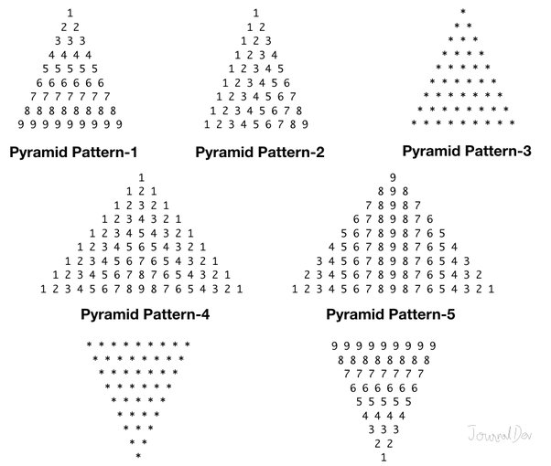
With some guess, the above problems can be done by many and those are common exercises which normally a beginner programmer does. If a beginner learned algorithmically, then programming on following simple pictured based exercise should not be a problem, because it based them on the same type of algorithmic thinking.

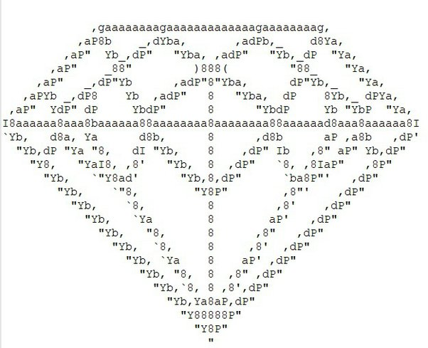
Programming is not about memorizing programming logic or downloading standard college/university level algorithms by practice in our mind, rather we need to understand the approach to solve a problem.
Learning with such simple picture-based problems surely helps in improving coding skills. If we apply the wrong logical condition then the non-matching output will be generated. This will also be learning, since on different occasions of solving a problem we may need such logical conditions. So, failures will become our lessons. Learning in this way makes learning interesting and forces us to put effort & focused. So, in this way, it helps in the logic building.
On the other hand, learning using mathematically based problems like prime numbers and other similar kinds of problems don’t create much of interest and on practical grounds, it is boredom on steroids for most of the beginners.
In my opinion, the pattern-recognition based problem gives a lot of reasons to think logically in different directions and to work on it. The improvement in building logical skills and in combination to learn with interest is very much higher, than any other approach.
In general, it suits all learners who invest some consistent time and I had experimented with this with a lot many students and I found this the most interesting way to learn to program quickly.
Trial Error KungFu VS Algorithmic Way.
The programmer should be able to visualize the logic clearly even before writing the program. This quality is possible only when a programmer is practiced to such a level to visualize clearly how any repeating control structure works or looping. Simple picture-based exercises help greatly in that regard which is basically based on a nested loop.
The main idea behind the selection of pictorial pattern based exercises is that it clearly validates the programmer’s logic. The mismatching output forces learner to think for an appropriate reason. This method of repetitively working on programming logic to get the matching output greatly helps in perfecting the visualization of programming logic.
Pattern-reorganization based problems are definitely a sure way to improve coding skills if followed a proper approach and not by applying dozens of guesswork to solve a particular problem. Otherwise, a person will get somewhat improved in guessing. Guessing is not all science and which is basically against the very definition of the algorithm.
Developing fertile ground for Visualization of programming logic Should be the prime focus of an absolute beginner. Unfortunately, this perspective is almost alien not only to most of the beginners but also among the teaching group as well. The next thing will be writing efficient code and it requires having a detailed study of data structures, algorithms, and their space & time-complexities.
Without sufficient logic building skills, the efforts on learning
(Data-structures +Algorithms )
will be like actually talking to Gorilla, it will not be productive.
In the data structure, there are graph algorithms, tree algorithms, and search and sorting algorithms. Likewise, there is a standard way to solve the pattern-based problem which clearly refines our fundamental logical skills.
If pattern-based problems are not handled properly it reveals logical weaknesses of a programmer and this the main reason whether in ;
campus interviews,
junior-level interviews,
at the school level exams,
beginners at college level exams,
as a learning aid to refine logical skills the pattern-based problems may appear.
Most of the places programming is taught by guesswork or they encourage them to remember the logic of a program. Even our school/college education is quite inclined to it. This is something like converting programming into a subject of history by killing the soul of programming, that is the algorithm usually followed.
The framework to Develop/Improve Program’s Logic: We Capture the process in the following approach which is nothing but a programming logic building exercise of one of its kind. It depicts the key steps of the approach in the following picture.
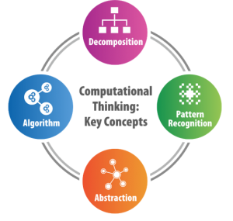
Source: Computational Thinking in K-12 Education - CSpathshala
Usually, learners try to implement a program by applying random guessing which is the root cause of a bad way of learning. The mentioned book will take you to an algorithmic way to solve the pattern-based problems and not by applying random guessing. We can never reach far by short-cuts or by sacrificing the actual values of a subject. We must learn the subject in the right way, the algorithmic way.
Resources: -
JAVA 21# Game -Changer Chronicles

Amazon.com: Java 21#Game-Changer : Classroom Chronicles - A Case Study Approach ( Hands-on project use-cases ): Core Java. Java Virtual Threads. Java Collections. eBook : Yakub, Mohmad : Kindle Store
https://www.amazon.com/dp/B0CKY7JY4B

Free Playlist for Python beginners.( Expect more in future…)
The definitive guide for Beginner’s Excellence for logic-building skills.
Note: Available in all amazon’s marketplace, please search as per your territory.
Java Programming Language:

ICSE Computer Applications Class 9 Java: Mastering Logical Skills: Yakub, Mohmad: 9781074482169: Amazon.com: Books
https://www.amazon.com/dp/1074482166

C Programming Language:

Amazon.com: c programming textbook.c programming book.c programming language.c programming.c programming visual quickstart guide.: c programming for dummies.absolute beginner's.beginner.exercises.in easy steps. eBook : Yakub, Prof. Mohmad: Kindle Store
https://www.amazon.com/dp/B07VL6CHZH

C++ Programming Language:
Only programming book in 9 Best Logical Thinking Books for Beginners - Book Authority.
8 Best Logical Thinking Books for Beginners

Amazon.com: C++ Programming for logical thinking.Computer Programming. Algorithmic thinking.Computational Thinking.: how to program.how to build logic in programming eBook : YAKUB, MOHMAD: Kindle Store
https://www.amazon.com/dp/B07VTQ8JVB

JavaScript Programming Language:

Amazon.com: javascript programming pattern looping intelligence to code logic eloquent way to learn to code for dummies & beginners fast: javascript effective crash course to gain confidence in coding quickly eBook : YAKUB, MOHMAD: Kindle Store
https://www.amazon.com/dp/B07RCKL3ZV

Python:

python Logic Mastery - Learning Python Programming Through Algorithmic Thinking for Beginners.: #1crash course to unlock confidence in coding using logical, mathematical, and computational thinking.
python Logic Mastery - Learning Python Programming Through Algorithmic Thinking for Beginners.: #1crash course to unlock confidence in coding using logical, mathematical, and computational thinking. eBook : Yakub, Mohmad: Amazon.in: Books
https://www.amazon.in/Python-beginners-computational-thinking-Programming-ebook/dp/B08XBGL3RC/ref=sr_1_1?crid=31Y3ZAI1QEAAI&keywords=mohmad+yakub&qid=1651116360&sprefix=mohmad+%2Caps%2C1006&sr=8-1

The book explains the approach to solve any pattern-based problems. This case study teaches how to build the logic right while thinking algorithmically. It shows how anyone can develop logic-building skills just from the very minimal, even without a CS background.
If you like the book or article, please share it with the needy.
Amazon has a 7-day return policy with a full refund. I will be very much thankful to you if any of you like to review this work and to give some feedback.
Learn happily and follow work ethics, definitely eventually become a talented programmer!!!
Failure taught me things about myself that I could have learned no other way.
- J.K. Rowling
A Humble Request:
If possible please suggest in your school/college and to your teachers.
If someone is able to understand any subject, then it takes a good amount of effort to make that subject interesting to others. In this way, you can help your teachers/lecturers.
Even many of my friends who were good in programming were not able to help me much during my college days and they tried their best. This book is an answer to that vacuum, which many non-confident learners feel while studying.

………………………………………………………………………………………………………………………………………………………………………………………………………………………………………………………………………………………………………………………………………………………………………………………………………………………………………………………………………………

Computational Thinking
Programming is a very close relative of common sense and so virtually everybody has the capacity to learn to program. There is no harm in trying and failing when we put our efforts toward earning a skill. Failures and setbacks are just the price to be paid to acquire a skill. Failure is our true teacher which guarantees to teach us in various ways on different occasions. In order to become knowledgeable in programming, one need only follow this simple rule: fail fast to learn fast. To learn a new subject quickly, we need to experiment in many different ways according to a plan and this demands interest. Without genuine interest, it is almost impossible to be consistent with any kind of learning. It is my observation that for most absolute beginners this unique approach of juggling with numbers based on mathematical fundamentals in order to practice the skill of programming is simply boredom on steroids. Developing a fertile ground for the visualization of programming logic should be an absolute beginner’s prime focus. Unfortunately, this perspective is alien to many beginners and even teachers. Many novice programmers and many frustrated programmers ask similar questions which are as follows.
“How to learn to program?”
“How to develop logic-building skills?”
“How to learn to code?”
“How to improve programming logic?”
Programming is an applied field. If a programmer who is weak in programming logic is not a programmer even. We know that complaining is the easiest job and if someone is expert in that haven’t actually achieved anything big. Whenever there is a problem, we just need to think “what could be the easiest possible way out?”

The Right Approach
First and foremost, beginning programmers should focus on developing their logic-building skills. Basic command of programming logic will give new programmers the confidence to deal with heavier topics and learn the features of a programming language in depth. If instead, the beginner focuses mainly on learning the syntax and features of a particular programming language, progress will be slow and frustrating. In order to become confident in any programming language, the first step should be to gain some level of proficiency to self-hack programming logic. I strongly recommend that novice learners initially pay more attention to developing their programming logic skills than to the features of a given programming language. This book is dedicated to installing the skills of programming logic in the mind of the learner. Additionally, if you are among those who have limited time to learn programming, this guide can serve you well too. It often happens that a beginner may know almost all the concepts of a programming language but still feel that something is missing. The missing element is sufficient logic-building capability. Without it, the beginner spends a lot of time being stuck and confused. This can lead many learners to lose interest. For example, we wouldn’t expect a person who is weak in basic math to take a strong interest in secondary school math or higher studies in mathematics. Weakness in the basics of a subject kills confidence sooner or later.
Participation in sports helps a person gain stamina, patience, discipline and resilience. Programming is similar. By practicing programming logic, a person builds their brain muscle, learns to focus, develops patience and definitely learns to adopt the attitude of “let’s bounce back” when faced with a setback. Programming is a self-disciplined, self-motivating activity that truly encourages a person to fight and sustain themselves against long odds. Programming encourages a person to become a “Problem-Solver”. Indirectly, it makes a person more sportive. Therefore, programming is not just for those who want to build a career: anyone can take up programming as a hobby. Thus it is an easy guess why Steve Jobs said,
“Everybody in this country should learn how to program a computer, because it teaches you how to think.”
You can’t manage what you can’t measure.
- Peter Drucker
The most important aspect of calculation or measurement is that it gives clarity. We will try to tap this “clarity” factor to get the hidden programming logic right using computational thinking. Following are the basic steps of computational thinking that can help beginner programmers to learn the fundamentals of algorithmic thinking;
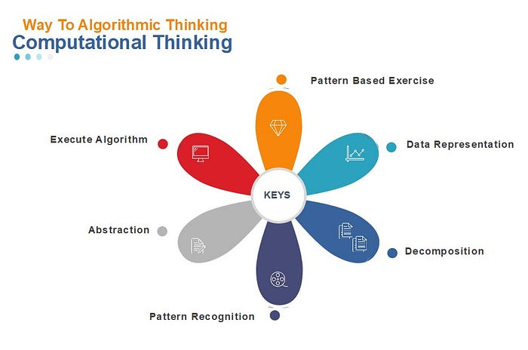
Created by Author from Windows MS-Office default templates.
Pattern-Based Exercise: To learn logic-building skills or fundamentals of algorithmic thinking, pattern-recognition-based exercises are a fun way to learn it. It just pulls-off all the pressure of learning, since it required minimal technical baggage. I find this is, the most efficient way to learn for beginners or teach coding to a beginner of any age-group.
Data Representation: Expressing a problem in terms of data or just associating relevant data helps to understand the problem and its needs. Basically, it gives some clarity.
Decomposition: Breaking down an actual problem into parts.
Pattern Recognition: Observing trends in data. Spotting the pattern behavior, their differences, and similarities.
Abstraction: Observing trends in data. Spotting the pattern behavior, their differences, and similarities. Replacing trends in data using logical expressions made up of variables, because variables represent a range of data.
Execute Algorithm: After discovering required logical expressions it is to set steps and rules for the algorithm. Implementing the program based on the algorithm and verifying the result by executing it.
Let’s try to understand these steps of computational thinking by applying them to the following pattern-based example.

Suppose our programming job is to print this logic-based pattern on a part of the computer screen. We will assume our approach that the computer screen is a combination of rows and columns virtually dividing it into smaller boxes. The smallest box treated as a resident of just a single character only. The address in each smallest box on the display screen will logically become a unique (row, column) numeric combination. With this assumption computer screen will simply uniquely combine (row, column) numeric value paired boxes which are uniformly spread all across the screen.
Data Representation
Although it is logical, we can almost locate the position of each printable character on the display screen by knowing its uniquely identifiable (row, column) numeric paired-values.
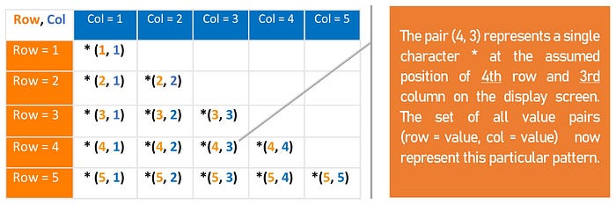
Computer dominantly works on very precise calculations. One of the interesting ways to practice programming is to try converting manual steps of writing a pattern into programming instructions. We can use paper or a spreadsheet. We can mark row numbers and column numbers to logically identify position-indicators to analyze a pattern correctly.
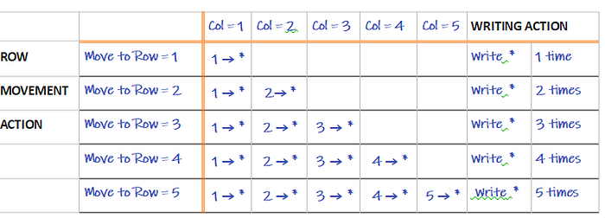
Decomposition And Pattern Recognition:
We can decompose our repetitive actions of printing pattern into the following categories
Repetitive Actions
a) Row Level: Repetitively moving down, marking the next row number in sequence-wise.
b) Column Level: Repetitively writing * characters at the column level.
The pattern is a 2-dimensional simple picture we can express such that it in terms of rows and columns. Our next step will be to transform these manual, repetitive actions into a working program. We will use * characters in our program to print it on the computer screen.
COLUMN LEVEL REPETITIVE ACTION: The table decomposes the pattern into the relationship of one-to-many between row and column values.
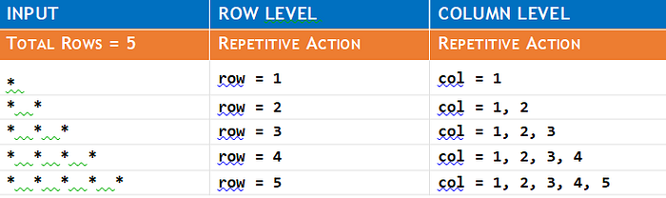
For uniquely identifying each printing character of a pattern let’s consider variables row and col. Choosing variables row and col to precisely mark printing character’s row and column number position respectively in a pattern. Every value of the variable: row can be mapped to a set of variable: col values at the column level. The variable: col values maintain a common difference of value 1 if we move from starting value to the ending value. Wait for a second, doesn’t it very much sound like another case of for-loop construction.
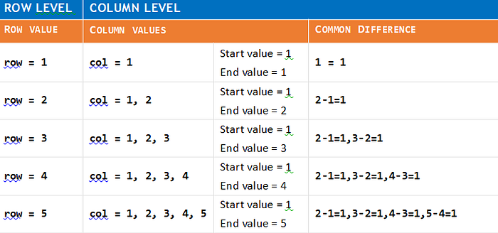
By considering variable: row and variable: col we can further refine the logic trace table intending to build for-loop against each value of row number. The for-loop will be basically a nested-loop for each row’s value. Based on the updated logic trace table we can write the program’s logic given as follows.
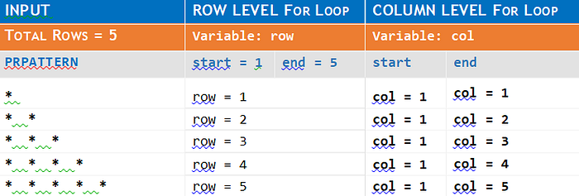
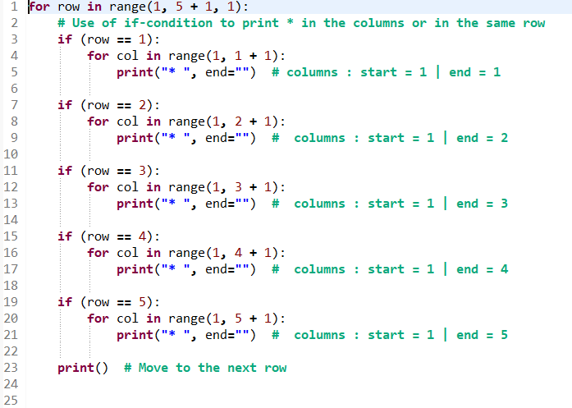
Abstraction:
The next step in generalization will be to convert many nested-loops into one nested-loop. Such conversion to a single nested-loop suggests that the number of rows inputted to the program should not affect our version of the solution. We will see all these in action while applying the principles of the logic trace table. Primarily, our goal will be to get consistent numeric or logical expressions in the columns of the logic trace table. We will use these consistent numeric or logical expressions to design the logic of our program and that is, the most essential learning. Derived expressions considered correct only when it gives correct output, otherwise, we need to re-work on the logic trace table to find out our own mistakes. This is the “computational thinking” way to learn the design of the program’s logic as compared to the trial-error method.
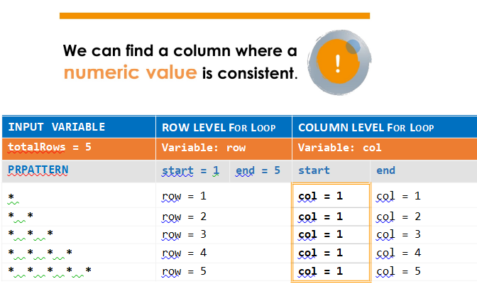
The column start contains the data col = 1 which is the same for every row. Hence, column start is already being in generalized state and hence we got the consistent logical expression in order to start the column level for-loop. The column level for-loop must require a singular starting value and a singular end value.
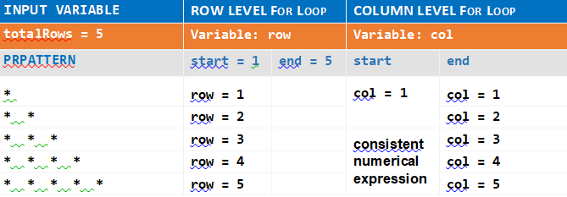
Clearly, the column end with singular value is not our case. The other remained possibility is to derive a logical expression that should be consistent with this column. We can observe numeric pattern variations of the variable: col and the variable: row. The column end matches exactly with numeric pattern variations of the variable: row, shown in the above logic trace table.
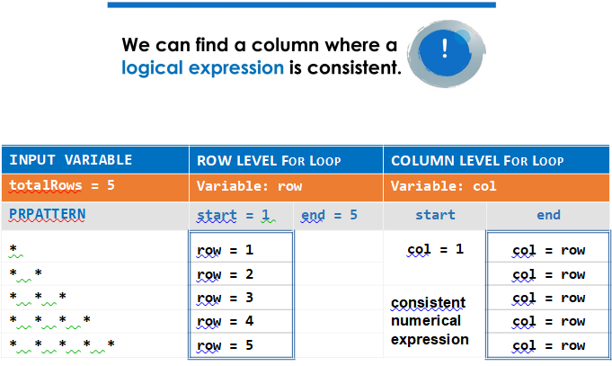
It means column level for-loop with variable: col starts at value 1 and ends at the most recent value taken by the variable: row. Hence, we got the consistent logical expression (col = row) for the column end.
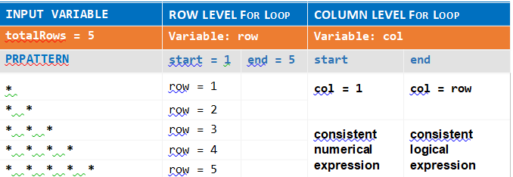
So, during the execution of the program row-level for-loop with variable: row takes the value 1 to 5. Then column level for-loop with variable: col will take values between 1 and the current value of the variable: row.
Mathematically, it can be given as
1 <= col <= row
Where row = 1 to 5
The row-level for-loop will get started at the value 1 and a changing value of a variable: row during the execution of the program will stop and control it. At each row’s value how column level for-loop should stop looping and controlled by the logical expression (col <= row). The consistent logical expression ( col <= row ) will be the reason to produce dynamic output at the column level for different values of variable: row. Extracting the consistent logical expression is a way to generalize and to get a customized solution. When we can establish a relationship between variables, then we can automate computing. We can now clearly define the action of column-level for-loop.
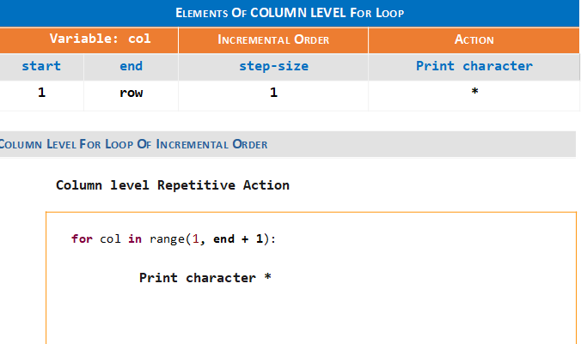
The following logic trace table is basically for-loop in action at row level. The only action expected from row-level for-loop in our case is to shift the program’s control to the next row. We should do it dynamically based on the total number of rows inputted by the variable: totalRows. Our target is to get singular numeric/logical expressions for the start and end of a row-level for-loop.
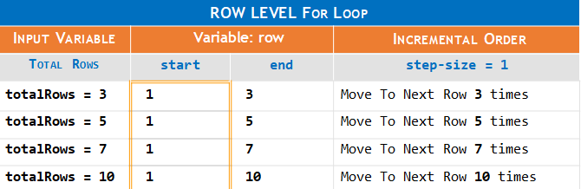
After doing numeric pattern matching and applying replacement using variable: totalRows, the logic trace table looks like the following.
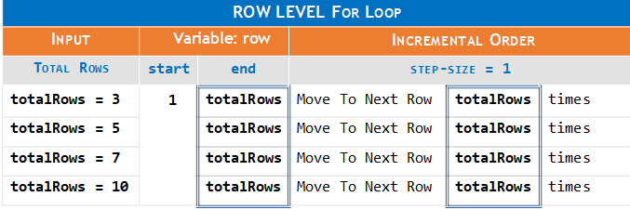
The following logic tracing table suggests that maximum repetition of row-level the value stored in the variable: totalRows can control for-loop and moving program’s control to the next row. Now, the stored value of totalRows will act as the maximum boundary value for the row-level for-loop repetitions. This is the way it plans a flexible solution to resize the length of the pattern based on the given input value of the variable: totalRows.
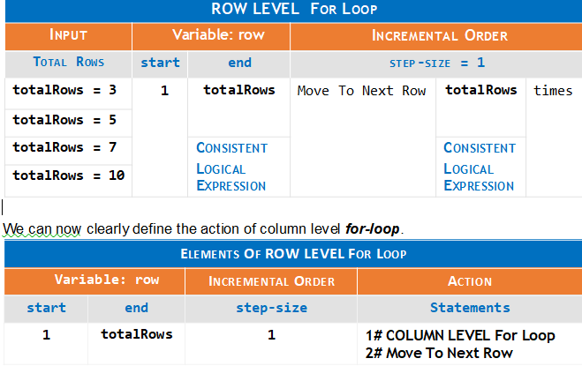
Algorithm:
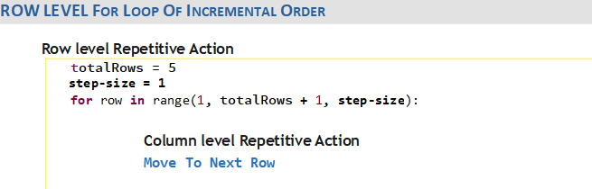
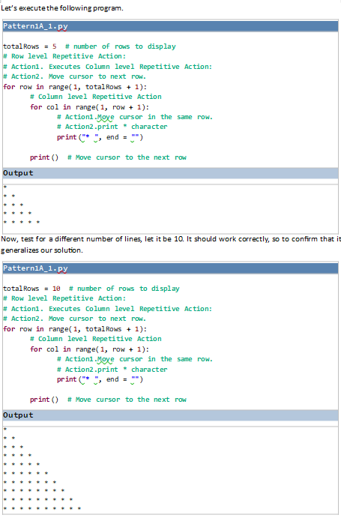
Applied knowledge is wisdom. To understand the importance of computational thinking, please try to solve the following given problems and improve something about logic-building skills.

For Java 21

Java 21#Classroom Chronicles - A Case Study Approach ( Hands-on project use-cases ): Core Java…

Java 21#Classroom Chronicles - A Case Study Approach ( Hands-on project use-cases ): Core Java. Java Threads. Java…
www.amazon.com

To develop or improve logic-building skills, interested ones can refer to the following resources.
Python for kids and beginners
https://www.amazon.com/dp/B09SW4TKYC
Java

Java: The Complete Reference for Pattern Programming: A NON - BORING way to learn programming logic…

Java:The Complete Reference for Pattern Programming: A NON - BORING way to learn programming logic & design. [Yakub…
www.amazon.com

JavaScript

JavaScript Programming Pattern: Looping intelligence

JavaScript Programming Pattern: Looping intelligence [YAKUB, MOHMAD] on Amazon.com. *FREE* shipping on qualifying…
www.amazon.com

C++

C++ Programming for Logical Thinking: Improve Coding

Amazon.com: C++ Programming for Logical Thinking: Improve Coding (9781086328073): YAKUB, MOHMAD: Books
www.amazon.com

C Programming

c programming. c programming book. c programming language. c programming for beginners. the art of…

Amazon.com: c programming. c programming book. c programming language. c programming for beginners. the art of…
www.amazon.com

……………………………………………………………………………………………………………………………………………………………………………………………………………………………………………………………………………………………………………………

Technical panelists always expect the programmer to be good at programming logic. A matter of fact is if a learner has got that confidence, then further advance technical learning will also be with much confidence.
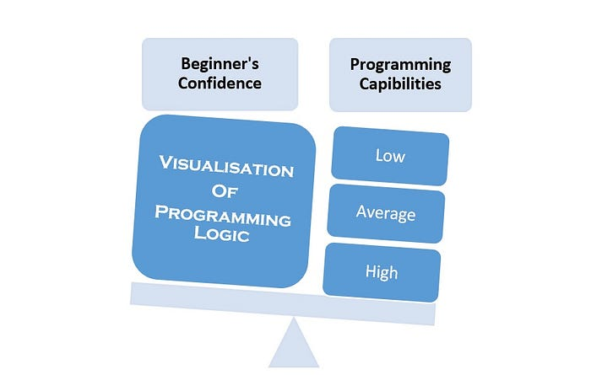
In a nutshell, beginner’s confidence in programming capabilities has a direct relation with their low/average/high level of visualization of programming logic.
In the learning of any subject when the visualization and thought process becomes active then only it will become actual learning. The outcome is that the person will understand the concept and apply the concept naturally.
Solve pattern-recognition-based problems because it will improve the visualization of logic. After some level of practice, your mind will work like a mini debugger where you could be able to visualize the flow of data and how different variables are taking values at the fresh point of execution of code.
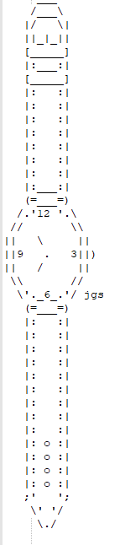
If a problem is asked in the interview or anywhere else, then we should be able to get the logic correctly in a single chance, instead of guessing. For example, consider this case where the programmer is expected to write a generalized solution so that based on input he/she is able to generate a wristwatch of customized sizes.
Programming is not about memorizing logic or downloading standard college/university level algorithms in our mind, rather we need to understand the approach to solve a problem. Developing a fertile ground for visualization of programming logic should be the prime focus in initial learning. Unfortunately, this perspective is almost missing.
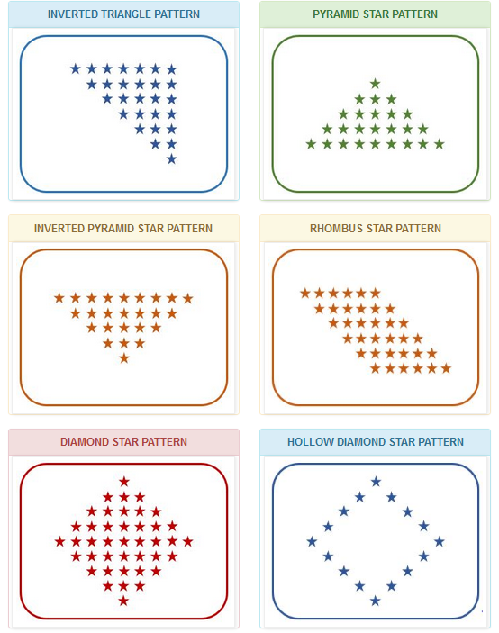
Pattern-based problems are definitely a sure way to improve coding skills if followed in a proper approach and not by applying dozens of guesswork, just to solve a particular problem. Usually, learners try to implement the program by applying random guessing, which is the root cause of the bad way of learning. Guessing is not at all science and so can’t be computer science either. This will be basically against the very definition of the algorithm. Practice on distinct patterns helps in developing visualization of logic. These are just a few of them and better to practice with many possibilities. For a working example, please refer to the following post.

Wise Head Junior: Computational Thinking To Algorithmic Thinking.

Without a doubt, every subject has some key fundamental basis. If key concepts of any subject truly internalized, then…
yakublancer.medium.com

The pattern-based problem gives a lot of reasons to think logically in different directions and to work on it. The improvement in building logical skills and with interest is much higher than any other approach. On an experimental basis, this is one of the most interesting ways to learn to program quickly. Learning to use mathematically based problems doesn’t create much interest and on practical grounds, I find it is boring on steroids for most beginners. It will require the next thing to have a detailed study of data structures, algorithms, and their space & time-complexities.

Without sufficient logic building skills, the effort on learning Data-Structures and Algorithms will be like talking to an actual Gorilla, it will not be productive.
In data-structure, there are graph algorithms, tree algorithms, search and sorting algorithms. Likewise, there is a standard way to solve the pattern-based problem which clearly refines our fundamental logical skills. If pattern-based problems are not handled properly, it reveals logical weaknesses of a programmer. Remembering the logic of a program is something like converting programming into a subject of history, by killing the soul of programming, that is not algorithmic thinking. Without a doubt, logic-building skills related to programming are a difficult subject to teach, and teachers or training staff to search for the guidelines. Whether self-learning, logic-building skills or teaching it using pattern-based exercises is the easiest way out to create interest and confidence in the learners. We must learn/teach the subject of programming in the right way, only in the algorithmic way. I captured this complete thought process in the following eBooks which is nothing but a programming logic building exercise of one of its kind.
Java Programming:
https://www.amazon.com/dp/1073437515
The mentioned book will take you to an algorithmic way to solve the pattern-based problems and not by applying random guessing which is often taught by many. We can never reach far in learning by short-cuts or by sacrificing the actual values of a subject.
This book is an answer to that vacuum, which many non-confident learners feel while studying programming.
Also available in different programming languages.

PYTHON. Wise Head Junior.: Beginners Guide To Programming. Coding For Kids. Learn With Fun. Learn…

PYTHON. Wise Head Junior.: Beginners Guide To Programming. Coding For Kids. Learn With Fun. Learn Logic Building…
www.amazon.com

JavaScript Programming Pattern Looping intelligence: Learn To Code Quickly With This Beginner's…

How can I improve my coding skills? This book has a unique approach, specially crafted for non-programmers/beginners. A…
www.amazon.in

C++ Programming for Logical Thinking. Improve Coding. Learn wisdom of programming from minimum…

C++ Programming for Logical Thinking. Improve Coding. Learn wisdom of programming from minimum.: Fundamentals of…
www.amazon.in

C Programming Patterns Logic - First Approach: Language fundamentals.Algorithmic Thinking.Beginners…

C Programming Patterns Logic - First Approach: Language fundamentals.Algorithmic Thinking.Beginners to Intermediate…
www.amazon.in

A Humble Request: - It takes a good amount of effort to make that subject interesting to others. If possible, please suggest in your school/college and to your teachers.
Amazon has a 7-day return policy with a full refund. No way you will be at a loss.
These books are specially put to easily fill the much-needed gap in logic building skills which most of the books in programming missed and so it is especially for: -
- WHO IS UNAWARE OF ANY APPROACH TO BUILD PROGRAMMING LOGIC?
- WHO HAD A HARD TIME LEARNING TO WRITE A PROGRAM?
- WHO ARE TEACHERS/TRAINERS AND LOOKING FOR A RELIABLE RESOURCE TO CREATE INTEREST IN THE SUBJECT OF PROGRAMMING FOR THEIR STUDENTS?
- WHO HAD SOME EXPERIENCE IN PROGRAMMING AND NOT CONFIDENT ENOUGH?
- WHO CARRIES THE FALSE NOTION THAT CODING IS ONLY FOR SUPER-SMART PEOPLE.
- WHO IS LOOKING FOR A 1ST SOLID MOVE TO BECOME A SELF-TAUGHT PROGRAMMER?
- WHO HAD SOME EXPERIENCE IN PROGRAMMING WITH PATTERN AND LOOKING FOR A STANDARD APPROACH TO GET THE LOGIC RIGHT FOR ANY LOGIC BASED-PATTERN?
. WHO IS THE VICTIM OF DISCOURAGEMENT COMMENTS, SIMILAR LIKE THE FOLLOWING?
Actually, you aren’t interested.
You lack patience and determination.?
Your IQ is well below average.
Learn happily and follow work ethics, definitely sooner or later you will become a talented programmer!!!
Failure taught me things about myself that I could have learned no other way.
- J.K. Rowling

